SCHOOL

Year 11 Examination, 2013

Question/Answer Booklet

MATHEMATICS: SPECIALIST 3A/3B
SOLUTIONS

Section Two:

Calculator-assumed

Student Number: In figures

In words

Your name

Time allowed for this section
Reading time before commencing work: ten minutes
Working time for this section: one hundred minutes

Materials required/recommended for this section

To be provided by the supervisor
This Question/Answer Booklet
Formula Sheet (retained from Section One)

To be provided by the candidate
Standard items: pens, pencils, pencil sharpener, eraser, correction fluid/tape, ruler, highlighters

Special items: drawing instruments, templates, notes on two unfolded sheets of A4 paper, and up to three calculators satisfying the conditions set by the Curriculum Council for this examination.

Important note to candidates

No other items may be used in this section of the examination. It is your responsibility to ensure that you do not have any unauthorised notes or other items of a non-personal nature in the examination room. If you have any unauthorised material with you, hand it to the supervisor before reading any further.

Structure of this paper

Section | Number of questions available | Number of questions to be answered | Working time (minutes) | Marks available | Percentage of exam
Section One:  Calculator-free | 7 | 7 | 50 | 50 | 33
Section Two:  Calculator-assumed | 12 | 12 | 100 | 100 | 67
 |  |  | Total | 150 | 100

Instructions to candidates

- The rules for the conduct of Western Australian external examinations are detailed in the Year 12 Information Handbook 2013. Sitting this examination implies that you agree to abide by these rules.

- Write your answers in the spaces provided in this Question/Answer Booklet. Spare pages are included at the end of this booklet. They can be used for planning your responses and/or as additional space if required to continue an answer.
- Planning: If you use the spare pages for planning, indicate this clearly at the top of the page.
- Continuing an answer: If you need to use the space to continue an answer, indicate in the original answer space where the answer is continued, i.e. give the page number. Fill in the number of the question(s) that you are continuing to answer at the top of the page.

- Show all your working clearly. Your working should be in sufficient detail to allow your answers to be checked readily and for marks to be awarded for reasoning. Incorrect answers given without supporting reasoning cannot be allocated any marks. For any question or part question worth more than two marks, valid working or justification is required to receive full marks. If you repeat an answer to any question, ensure that you cancel the answer you do not wish to have marked.

- It is recommended that you do not use pencil, except in diagrams.

Section Two: Calculator-assumed (100 Marks)
This section has thirteen (13) questions. Answer all questions. Write your answers in the spaces provided.

Working time for this section is 100 minutes.

Question 8 (10 marks)
(a) Plot and label the complex number 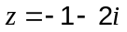 on the Argand diagram below. (2 mark)
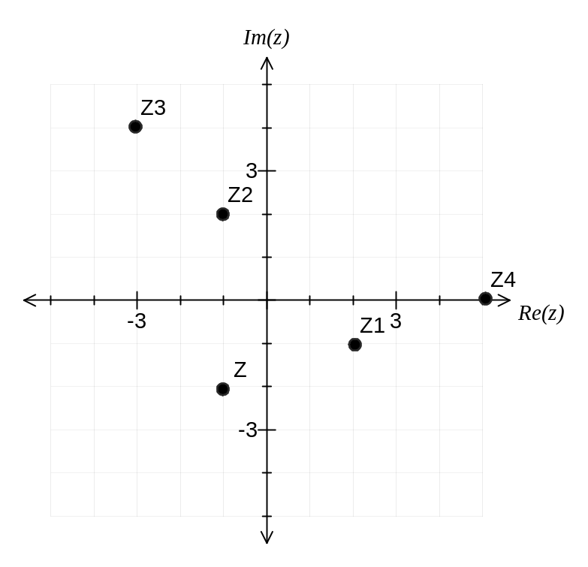
(b) On the same diagram plot and label the following complex numbers: (8marks)

(i) 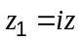
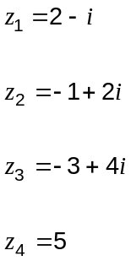

(ii) 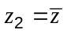

(iii) 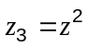

(iv) 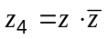

Question 9 (12marks)
The functions 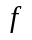 and are defined as 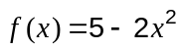 and 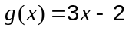.

(a) Calculate 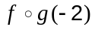. (2 mark)

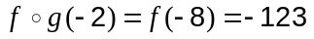

(b) Derive an expression for 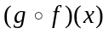. (3marks)
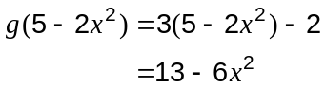

(c) State the domain and range of . (3marks)

Domain: 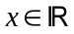

Range: 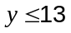

(d) Derive an expression for 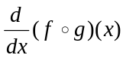. (2 marks)

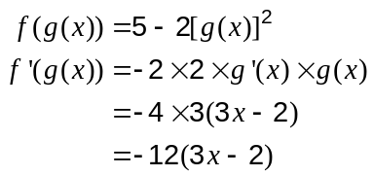

(e) Derive an expression for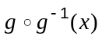, where 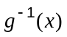 is the inverse of 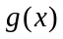. (2 marks)

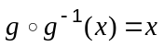

Question 10 (8 marks)
Relative to the origin, a small particle A is moving with velocity 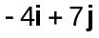 ms⁻¹ and another small particle B is moving with velocity 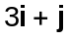 ms⁻¹.

(a) Calculate the angle between the velocities of A and B, rounding your answer to two decimal places. (2 marks)

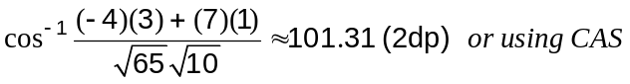

(b) Determine the velocity of B relative to A. (2 marks)

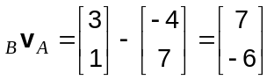

(c) What is the exact speed of B relative to A? (1 mark)

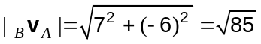

(d) The velocity of a third small particle C relative to B is 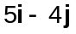. What is the exact speed of C relative to the origin? (3 marks)

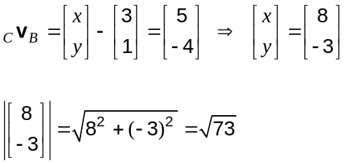

Question 11 (10 marks)
Caesium-137 is a common radioisotope used as a gamma-emitter in industrial applications and it has a half-life of 30.17 years. In an application involving sterilization of medical instruments, the mass (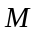 in milligrams) of Caesium-137 used in the system decays according to the relationship:
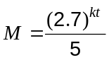
where is a constant and is the time (in years) since the system was manufactured.

There are 1 000 micrograms in 1 milligram.

(a) What mass of Caesium-137 was initially in the system, in micrograms? (2 marks)
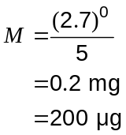

(b) Calculate the value of , rounding your answer to 3 significant figures. (3 mark)

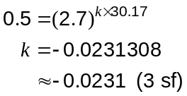

(c) What percentage of the original mass of Caesium-137 remains in the system after one year? (2 marks)
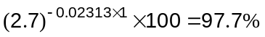

(d) The Caesium-137 in the sterilization system is replaced once its initial mass has fallen by more than 40 micrograms. After how many years and months would this be necessary?
(3 marks)
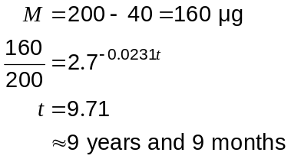

Question 12 (9 marks)
Consider the function 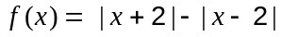.

(a) Graph  on the axes below. (3 marks)
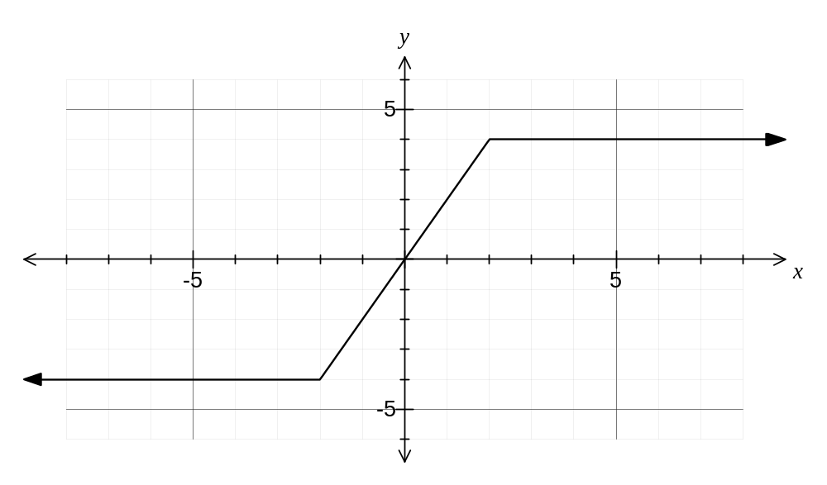

(b) Write a piecewise definition for the function . (3 marks)

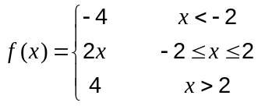

Another function is given by 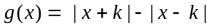, where is a positive constant.

(c) Write a piecewise definition for the function . (3 marks)

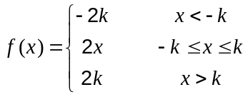

Question 13 (8 marks)
A function is continuous and differentiable everywhere and is defined by

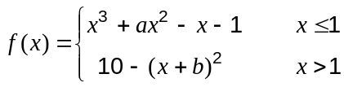

Determine the values of the constants and , where 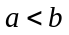.

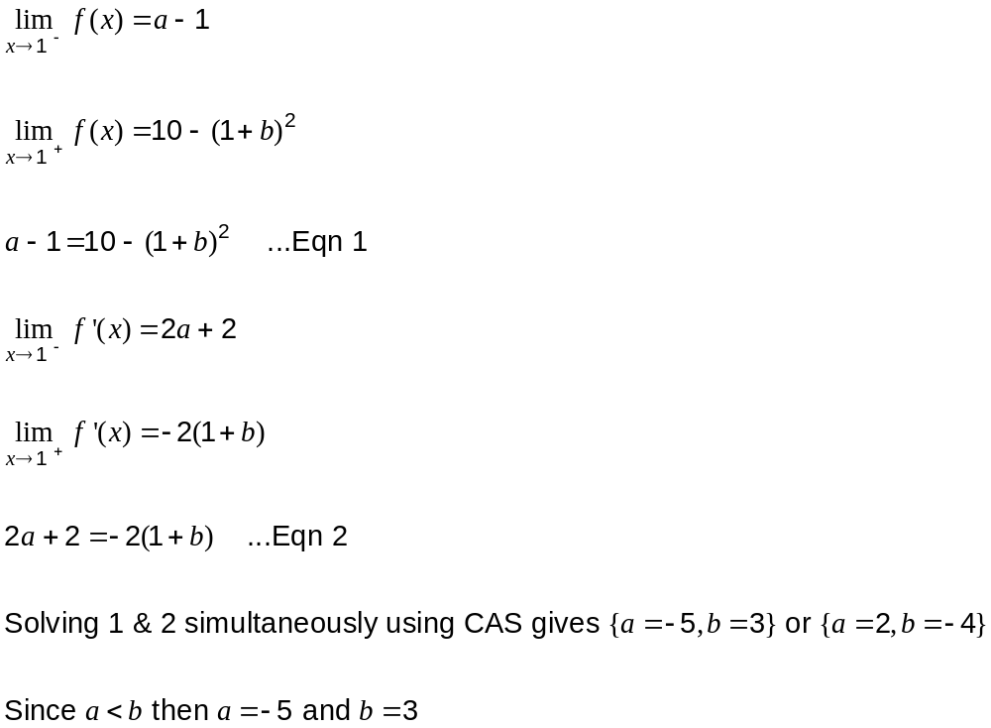

Question 14 (8 marks)
The function is defined by 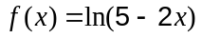.

(a) Draw and label the graph of 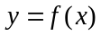 on the axes below. (3 marks)
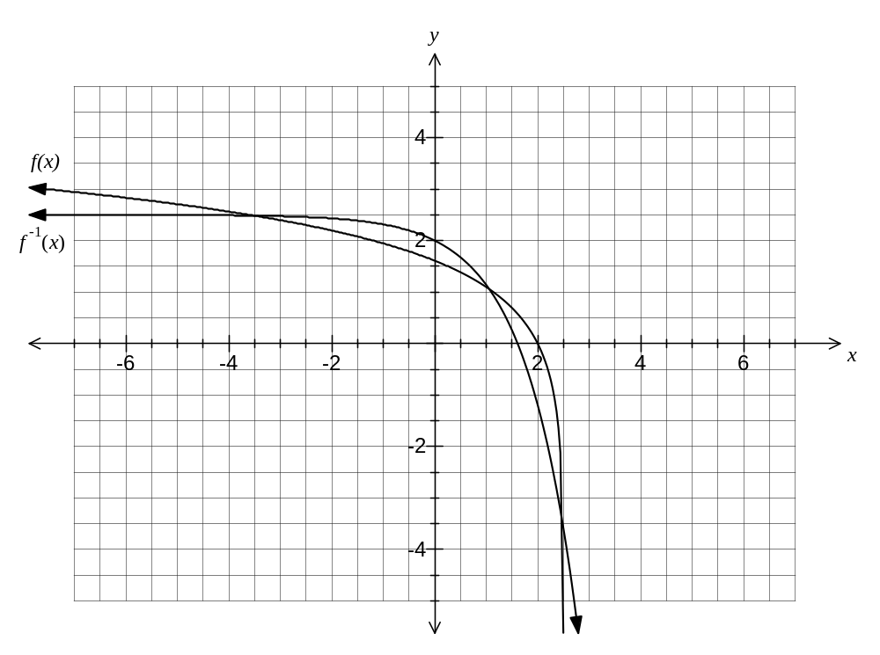
(b) State the domain and range of . (2 marks)
Domain: 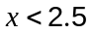

Range: 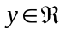

(c) Draw and label the graph of 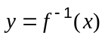, the inverse of , on the axes above.
(2 marks)

(d) State the range of 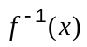. (1 mark)
Range: 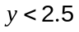

Question 15 (6 marks)
The points P and Q lie on a circle of radius and have polar coordinates 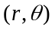 and 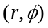 respectively, where 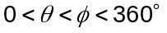.
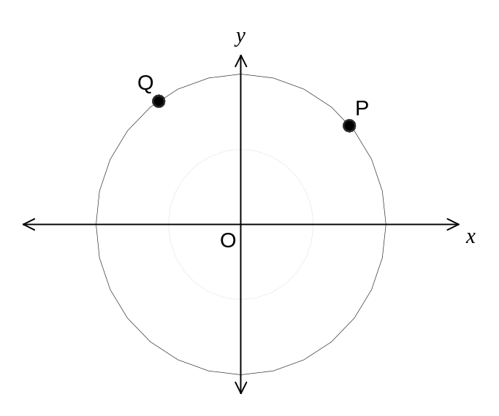
(a) Express both of the vectors 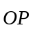 and 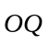 in the form 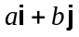. (2 marks)
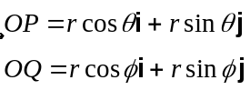

(b) Use your answers from (a) to show that 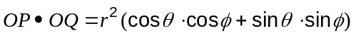. (1 mark)
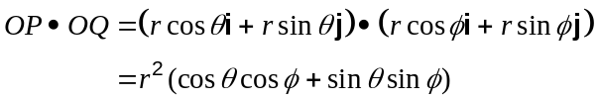

(c) Use the diagram above to state the size of 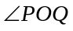. (1 mark)
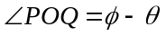

(d) Use the definition of the dot product on the formula sheet to show: (2 marks)

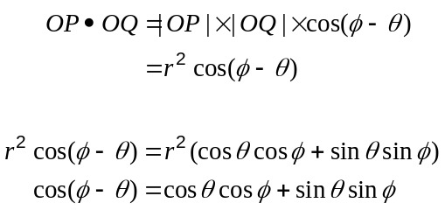

Question 16 (5 marks)
A proposed road has vector equation 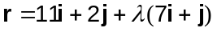. The road will pass through a circular nature reserve, the boundary of which is given by 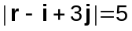. Given that all distances are in kilometres, determine the length of the proposed road that will pass through the nature reserve, rounded to two decimal places.

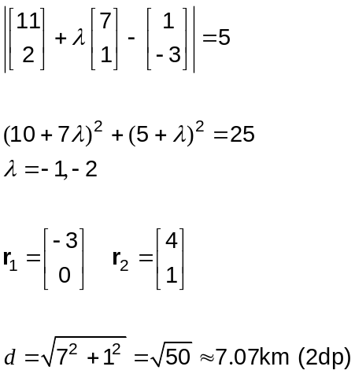

Question 17 (6 marks)
Prove the following identities:

(a) 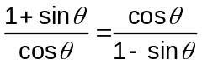 (3 marks)
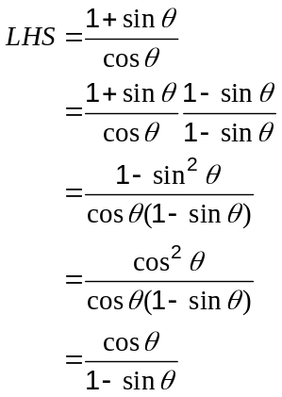

(b) 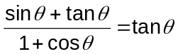 (3 marks)
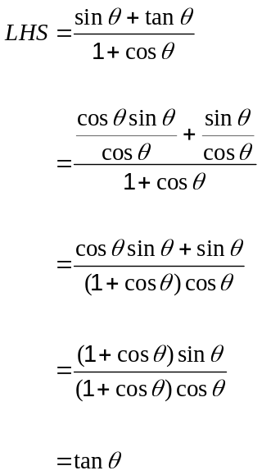

Question 18 (11 marks)
Points A and B lie on level ground with position vectors 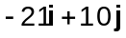 m and 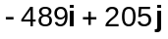 m respectively. A steady wind with velocity 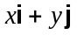is blowing across the ground.

In order to fly at a fixed height along the direct path from point A to point B, a small drone is programmed to fly with velocity 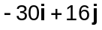 ms⁻¹.

(a) Show that the relationship between the coefficients and is given by 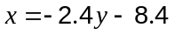.
(5 marks)
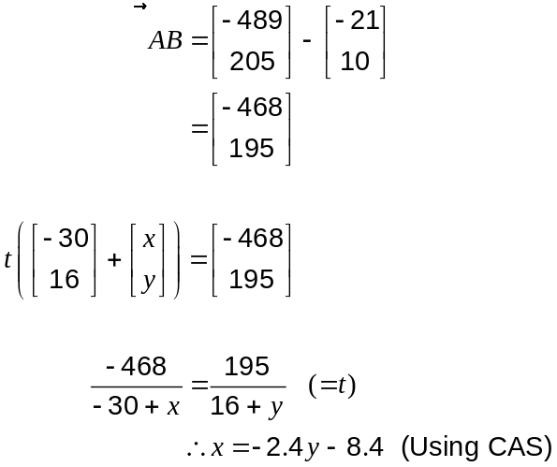

(b) Given that the wind has a speed of 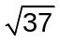 ms⁻¹, calculate all possible wind velocities.
(4 marks)
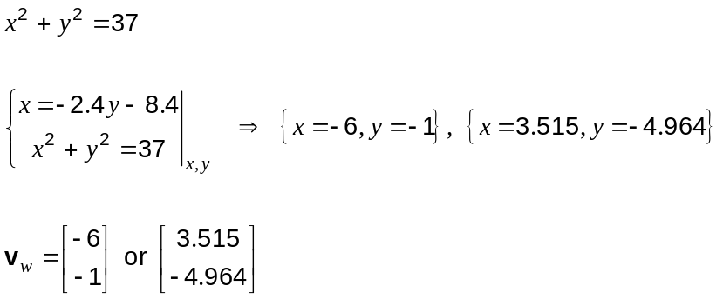

(c) Determine all possible times for the drone to fly from A to B. (2 marks)

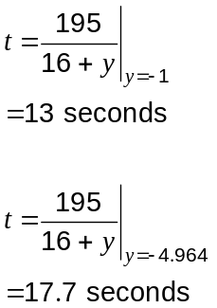

Question 19 (7 marks)
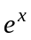 can be expressed as an infinite series as follows: 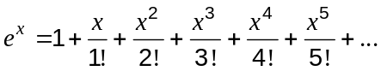

(a) Show how to use the first five terms of the above series to determine, to 3 significant figures, the value of . (2 mark)
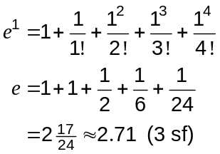

(b) Use the definition 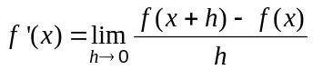 for the derivative of to show that if 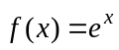, then 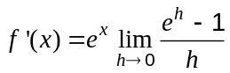. (2 marks)

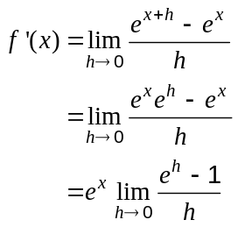

(c) Express 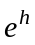 using the infinite series and hence show that 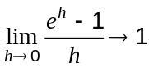. (3 marks)

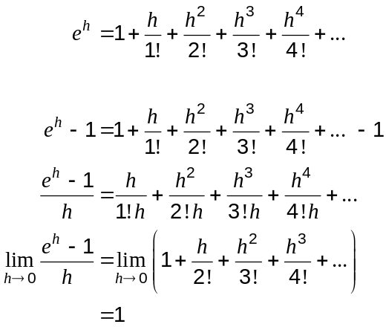

Additional working space

Question number: _________

Additional working space

Question number: _________

Additional working space

Question number: _________

Additional working space

Question number: _________

